诚信应考,考试作弊将带来严重后果！
_____________ ________
…

姓名 学号
学院 专业 座位号
( 密 封 线 内 不 答 题 )
……………………………………………………密………………………………………………封………………………………………线……………………………………线………………………………………

华南理工大学期末考试
《操作系统》试卷A
注意事项：1. 考前请将密封线内填写清楚；
2. 所有答案请答在答题纸上；
3．考试形式：闭卷；
4. 本试卷共 三 大题，满分100分， 考试时间120分钟。
题 号 | 一 | 二 | 三 |  |  | 总分
得 分
评卷人

- 单项选择题(20pts, 2pts each)
  - ( ) The ________ solution to the critical section problem will cause the situation that a process running outside its critical region may block another process.
A. Peterson’s Algorithm B. Banker’s Algorithm
C. Test and Set Lock D. Strict Alternation
  - ( ) If the time slice is too large, round robin scheduling algorithm may degenerate (退化) to _______scheduling algorithm.
A. First Come First Served (FCFS) B. Shortest Job First (SJF)
C. priority D. multiple queues
  - ( ) We define a semaphore, whose initial value is 3 (this means that the number of a certain resource is 3). Now, its value becomes to 1. Assume that M represents the number of available resource and N shows the number of processes waiting for this resource, then the value of M and N is _______ respectively.
A. 0, 1 B. 1, 0 C. 1, 2 D. 2, 0
  - ( ) The purpose of the page table is to map virtual pages into page frames. The ________ method is to avoid keeping all the page tables in memory all the time.
A. TLB B. multi-level page table
C. inverted page table D. hash algorithm
  - ( ) With the LRU page replacement policy, and enough space for storing 3 page frames, the memory page reference string “ABCABDDCABCD” would produce .
A. 6 page faults B. 7 page faults C. 8 page faults D. 9 page faults
  - ( ) Assume the reference count of file F1 is 1 initially. Firstly, we create a symbolic link file F2 linking to F1, and then create a hard link file F3 linking to F1. Afterwards, F1 is deleted. Now, the reference count of F2 and F3 is ______ respectively.
A. 0, 1 B. 1, 1 C. 1, 2 D. 2, 1
  - ( ) How many disk operations are needed to fetch the i-node for the file /home/John/test.txt? Assume nothing along the path is in memory. Also assume that all directories fit in one disk block.
A. 5 B. 6 C. 7 D. 8
  - ( ) I/O software is typically organized in four layers. Computing the track, sector, and head for a disk read is done in the ________ layer.
A. interrupt handlers B. device drivers
C. device-independent operating system software D. user-level I/O software
  - ( ) Windows takes _____ approach to handle deadlock.
A. the Ostrich B. detection and recovery C. avoidance D. prevention
  - ( ) Requesting all resources initially is often used to prevent deadlock to attack the ______ condition.
- mutual exclusion C. no preemption
- hold and wait D. circular wait
- 简答题(20pts total, 5pts each)
  - (5pts) In a virtual memory system, does a TLB miss imply a disk operation will follow? Why or why not?

  - (5pts) Please describe the relationship between a process and a program.

  - (5pts) What is purpose of the open system call in UNIX? What would the consequences be of not having it?

  - (5pts) A system has p processes each needing a maximum of m resources and a total of r resources available. What condition must hold to make the system deadlock free?

- 综合题(60pts total)
  - (10pts) In the Sim-City community Woobish most people smoke, but the laws of Sim City require that non-smokers be protected from passive smoke. So Woobish has a law under which people can only smoke in a bar if everyone in the bar is ok with it. If a designated non-smoker is in the bar, nobody can light up. Assume that customers are modeled as threads:
▪ smoking threads call enter_bar(true) before entering the bar (the flag is true to indicate that the thread is a smoker), then repeatedly call want_smoke() before lighting up, and done_smoking() after they finish, and finally call leave_bar(true) when leaving the bar.
▪ non-smoking threads call enter_bar(false) to enter (the flag is false to indicate a non-smoker), and leave_bar(false) on its way out.

Write the pseudo code for a semaphore implementing these rules. You can assume that periodically, there won’t be any non-smokers. This would make sense, at least in the first few years after Woobish passes the law, since non-smokers tend to leave the bar quickly (you would too, with all those angry nicotine-crazed smokers glaring at you!)

  - (10pts) Consider the following system snapshot using the data structures in the Banker's algorithm, with resources A, B, C, and D, and processes P0 to P4:
Process | Max | Allocation | Available
Process | A B C D | A B C D | A B C D
P0  P1  P2  P3  P4 | 6 0 1 2  - 7 5 0  - 3 5 6  1 6 5 3  1 6 5 6 | 4 0 0 1  1 1 0 0  1 2 5 4  0 6 3 3  0 2 1 2 | 3 2 1 1

Using Banker's algorithm answer the following questions.
- What are the contents of the Need matrix?
- Is the system in a safe state? Why?
- If a request from process P4 arrives for additional resources of (1,2,0,0), can the Banker's algorithm grant the request immediately? Show the new system state and other criteria.

  - (10pts) Consider a multi-level feedback queue in a single-CPU system. The first level (queue 0) is given a quantum of 8 ms, the second one a quantum of 16 ms, the third is scheduled FCFS. Assume jobs arrive all at time zero with the following job times (in ms): 4, 7, 12, 20, 25 and 30. Show the Gantt chart for this system and compute the average waiting and turnaround time.

  - (10pts) Consider the situation in which the disk read/write head is currently located at track 45 (of tracks 0-255) and moving in the positive direction. Assume that the following track requests have been made in this order: 40, 67, 11, 240, 87. What is the order in which Elevator Algorithm would service these requests and what is the total seek distance? And what about Shortest Seek First (SSF) algorithm?

  - (10pts) Suppose that you have file system consisting only of inodes and data blocks. Each inode contains 10 entries, each of which is 4 bytes in size.
- Suppose that inodes now contain 10 entries, of which 7 point to direct blocks, 2 point to single indirect blocks, and 1 points to a double indirect block. Data blocks and indirect blocks are both 1024 bytes in size, and indirect block entries are each 4 bytes in size. What is the maximum file size allowed by this file system?
- Suppose that instead of inodes, a file allocation table is used, and each entry in the file allocation table is 4 bytes in size. Given a 100 MB disk on which the file system is stored and data blocks of size 1024 bytes, what is the maximum sized file that can be stored on this disk?

  - (10pts) Consider the following segmented paging memory system. There are 4 segments for the given process, and a total of 5 page tables in the entire system. Each page table has a total of 8 entries. The physical memory requires 12 bits to address it; there are a total of 128 frames.
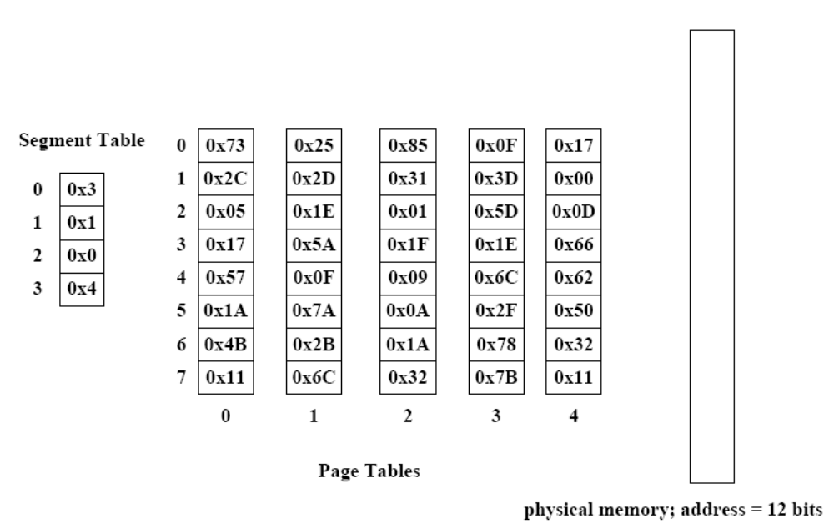
- How many bytes are contained within the physical memory?
- How large is the virtual address?
- What is the physical address that corresponds to virtual address 0x312?
- What is the physical address that corresponds to virtual address 0x1E9?

